Defining Named Storm
https://www.ncdoi.gov/consumers/homeowners-insurance/windstorm-and-hail
Quotes from NCDOI
Named Storm Percentage Deductibles

Named Storm Percentage Deductibles
Named storm deductibles are only triggered under specific circumstances. However, it’s important to talk with your agent and read your policy to understand the details of these deductibles so you are prepared in the event of a severe storm.
- "Named storm" means a weather-related event involving wind that has been assigned a formal name by the National Hurricane Center, National Weather Service, World Meteorological Association or any other generally recognized scientific or meteorological association that provides formal names for public use and reference. A named storm includes hurricanes, tropical depressions and tropical storms.

- Target Audience for article = Large Businesses or High Value Buildings near the coast
Image from: https://www.homeinsuranceking.com/blog/north-carolina-joint-underwriters-and-wind-pool-map-explained/
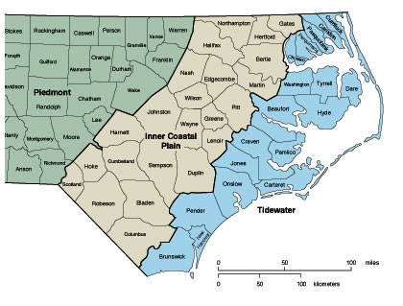
Explaination of the image: 41 Counties east of I-95 will need additional wind policies. Properties in these areas are considered high-risk and their normal property coverage will not include wind/hail.
The below examples assume your property is insured to value per the policy conditions, and there is no co-insurance deductible.
If a loss is the result of a named storm … Deductibles range between 1-5% of the policy limits for the damaged property.
Example #1
A $3,000,000 business building’s normal property deductible is $10,000. If it was a named storm, the deductible changes to 1% of the value of the proprerty. How much will the named storm deductible be for this loss?
Answer:
The deductible will be $30,000. Your policy would only cover the amounts exceeding the $30,000 named storm deductible.

$3,000,000 building coverage X 1% named storm deductible = $30,000 deductible

Example #2
A Carolina Beach Home valued $330,000 has a property deductible of $3,300. It was unfortunalty damaged by a named storm. Because of the location of the home, it is deemed high risk and has a 5% name storm deductible. How much will the named storm deductible be for this loss?
Answer:
The deductible will be $16,500. Your policy would only cover the amounts exceeding the $16,500 under the named storm deductible.

$330,000 home building coverage X 5% named storm deductible = $16,500 deductible

Example #3
There is a $500,000 home is located East of I95 (about 30 minutes away from the beach). Their roof is damaged from Hurricane Florence and the damage totaled to $20,000. The named storm deductible is 3% of their coverage. How much will their insurance carrier reimburse them for the damages?
Answer:
They should expect a payment of $5,000… after the homeowners pay their deductible of $15,000.
The policy would only cover the amounts exceeding the $15,000 deductible under the named storm deductible.
$500,000 home building coverage X 3% named storm deductible = $15,000 deductible
Damages $20,000 - $15,000 deductible = $5,000 Payment

Solution
Question: How to combat the high deductible?
Answer: Deductible buybacks

~More info needed ~

